SMART ELECTRICITY OUTAGE DETECTION AND RESTORATION SYSTEM

A MINI PROJECT REPORT

24GEP31 – Mini Project

Submitted by

NAME OF THE CANDIDATE(s)
ABIRAMI J
(25CSR003)
AJAY R
(25CSR007)
AKASH M
(25CSR010)

DEPARTMENT OF COMPUTER SCIENCE AND ENGINEERING



KONGU ENGINEERING COLLEGE
(Autonomous)

PERUNDURAI ERODE – 638 060

NOVEMBER 2026

DEPARTMENT OF COMPUTERSCIENCE AND ENGINEERING

KONGU ENGINEERING COLLEGE

(Autonomous)

PERUNDURAI ERODE – 638060

NONEMBER 2026

BONAFIDE CERTIFICATE

This is to certify that the Mini project report entitled SMART ELECTRICITY OUTAGE DETECTION AND RESTORATION SYSTEM is the bonafide record of project work done ABIRAMI J (Register No: 25CSR003), AJAY R (Register No: 25CSR007), AKASH M (Register No: 25CSR010) under my supervision for the mini-project requirement of the Bachelor of Engineering program during the academic year 2026–2027.

SUPERVISOR HEAD OF THE DEPARTMENT

Date:

Submitted for the end semester viva voce examination held on___________________

ABSTRACT

Managing electricity outages can be challenging for utility operators, especially when a feeder failure affects multiple consumer areas. Manually identifying all disconnected areas and deciding which repair should be handled first can be time-consuming and may result in delays, particularly when critical facilities such as hospitals and emergency centres are affected. It can also be difficult to track network changes and restoration progress after repairs.

To overcome these challenges, the SMART ELECTRICITY OUTAGE DETECTION AND RESTORATION SYSTEM is developed using Java, Object-Oriented Programming, graph-based data structures, and MySQL for persistent data management. The system represents substations, feeder lines, and consumer areas as a network and uses BFS/DFS to identify disconnected areas after a feeder failure. A PriorityQueue is used to prioritize repair jobs based on critical facilities affected and the total number of affected consumers. Repair teams can be assigned to faults, and predefined backup connections can be considered for alternate connectivity.

The implemented system provides a simple and user-friendly platform for monitoring electricity outages and restoration activities. By combining Java OOP concepts, graph algorithms, suitable data structures, and database connectivity, the system helps identify affected areas, organize repair work, and update network connectivity after completed repairs. This provides an efficient academic simulation of outage detection and restoration planning while highlighting the importance of reliable electricity infrastructure.

TABLE OF CONTENTS

ABSTRACT iii
CHAPTER 1: PROBLEM ANALYSIS AND DESIGN 1
  - Problem Definition 1
    - Problem Statement 1
    - Project Objectives 1
    - Functional and Non-Functional Requirements 1
  - SDG Relevance 1
  - Proposed System and Solution 1
  - Java OOP Design 2
  - Data Structures and Algorithms 2
  - System Architecture and Methodology 2
  - Project Planning and Risk Management 2
CHAPTER 2: IMPLEMENTATION AND TECHNICAL DEMONSTRATION 3
  - Technology Stack 3
  - Frontend Design and User Interface 3
  - Database Design and Connectivity 3
  - Implementation of Modules 4
  - Complete Working Demonstration 4
    - User Interface and Workflow Evidence (Screenshots) 5
CHAPTER 3: TESTING, RESULTS AND EVALUATION 7
  - Testing and Validation 7
  - Results and Performance Analysis 7
  - Sustainability, Cost and Resource Efficiency 8
  - Limitations and Future Enhancements 8
CHAPTER 4: GITHUB AND CONCLUSION 9
  - GitHub Repository and Version Control 9
    - Repository Overview & Folder Structure 9
    - Source Code & Execution Instructions 9
    - Commit History & Evidence 9
  - Conclusion 9
REFERENCES 10
APPENDIX (CODE) 11

CHAPTER 1

PROBLEM ANALYSIS AND DESIGN

1.1 Problem Definition:
The project aims to develop a Java-based system for detecting and restoring electricity outages in a simplified distribution network. The system models substations, feeder lines, consumer areas, critical facilities, and repair teams. When a feeder line fails, the system identifies disconnected areas using BFS/DFS traversal. Hospitals and emergency centres are given higher restoration priority. A priority queue is used to organize repair jobs based on their impact. The system also identifies predefined alternate connections while avoiding failed lines. Repair teams can be assigned to restoration tasks, and network connectivity is recalculated after each repair. Java OOP concepts such as encapsulation, inheritance, polymorphism, abstraction, and composition are applied. Data structures such as HashMap, HashSet, ArrayList, and PriorityQueue are used for efficient management of network and restoration data. The system should be reliable, maintainable, deterministic, and easy to operate through a menu-driven console interface.

    - Problem Statement
Electricity outages can disconnect multiple consumer areas and critical facilities, making manual fault detection and restoration difficult and time-consuming. The proposed Smart Electricity Outage Detection and Restoration System identifies affected areas, prioritizes restoration based on criticality, and manages repair activities using graph-based algorithms and Java data structures.

1.1.2 Project Objective
The main objective of this project is to develop a smart system for detecting electricity outages and efficiently managing their restoration. The system aims to identify affected areas, prioritize critical consumers, assign repair teams, and monitor the restoration process using graph-based algorithms and Java data structures. It also provides a web-based interface for easy monitoring and stores outage and restoration information in a database.

1.1.3 Functionl and Non-Functional Requirements

Functional Requirements
The system should detect and record electricity outages and feeder-line faults. It should identify affected consumer areas, prioritize critical areas, assign repair teams, and track the restoration process. The system should also provide a web interface for monitoring network status and store outage and restoration details in the database.

Non-Functional Requirements
The system should be reliable, efficient, user-friendly, and responsive. It should provide accurate outage detection and restoration status while maintaining data consistency. The system should also be maintainable, scalable, and capable of handling network updates with minimal processing time.

1.2 SDG Relevance:
This project is mainly aligned with SDG 7 – Affordable and Clean Energy, as it focuses on efficient electricity outage detection and faster restoration of power supply. It also supports SDG 9 – Industry, Innovation and Infrastructure by applying Java, data structures, and graph algorithms to improve the reliability of electricity infrastructure. The project is further related to SDG 11 – Sustainable Cities and Communities, as reliable electricity is essential for hospitals, emergency centres, and other critical services. By prioritizing critical facilities and reducing restoration delays, the system can help improve service reliability, public safety, and efficient management of electricity networks.

1.3 Proposed System & Solution:
The proposed system is a Java-based Smart Electricity Outage Detection and Restoration System that monitors a simplified electricity distribution network and supports faster outage management. The system detects failed feeder lines and identifies disconnected consumer areas using BFS/DFS graph traversal. Critical areas such as hospitals and emergency centres are given higher restoration priority using a PriorityQueue. The system manages substations, feeder lines, consumer areas, faults, and repair teams through modular OOP-based classes. It also checks predefined backup connections while avoiding failed lines. The terminal application provides the core outage detection, prioritization, repair assignment, and restoration functions, while the web application provides a visual network dashboard for monitoring faults, dispatching teams, completing repairs, and viewing restoration history. HashMap, HashSet, ArrayList, and PriorityQueue are used for efficient data management, with the web module also maintaining event and fault information through a database.

1.4 Java OOP Design:
The system is designed using Java OOP principles with Substation, FeederLine, ConsumerArea, CriticalArea, GeneralArea, FaultReport, RepairTeam, DistributionNetwork, and RestorationPolicy as the core classes. Encapsulation is applied by keeping network and fault data protected and providing methods such as failLine(), restoreLine(), and assignTeam() to control state changes. Inheritance is used where CriticalArea and GeneralArea extend the ConsumerArea class. Polymorphism allows these subclasses to provide different implementations of restorationPriority(). Abstraction is applied through the RestorationPolicy, which defines the logic for prioritizing restoration jobs without exposing unnecessary implementation details. Composition is used in DistributionNetwork, which contains substations, feeder lines, consumer areas, and fault information. Each module has a specific responsibility for network management, outage detection, fault reporting, repair-team assignment, restoration prioritization, and connectivity updates.

1.5 Data Structures & Algorithms:
The system uses an adjacency-list graph to represent substations, feeder lines, and consumer areas. HashMap stores network, fault, consumer, and repair-team information, while HashSet tracks visited nodes during connectivity analysis. ArrayList maintains outage events and restoration history. A PriorityQueue orders restoration jobs based on critical loads, affected consumers, and report sequence. BFS/DFS is used to traverse working feeder lines from active substations and identify disconnected areas. The workflow is: detect line failure → update network → traverse reachable nodes → identify affected areas → calculate restoration priority → assign repair team → restore line → recompute connectivity. For a graph with V nodes and E connections, BFS/DFS takes O(V + E) time and O(V) space. HashMap/HashSet operations are O(1) average, while PriorityQueue insertion/removal is O(log n). ArrayList operations such as adding history records are generally O(1).

1.6 System Architecture & Methodology

SYSTEM ARCHITECTURE AND METHODOLOGY
FLOWCHART
START
↓
Network Design
(Electrical Network as Graph)
↓
Fault Reporting
(Web Dashboard)
↓
Java Backend Processing
(OOP Concepts)
↓
Identify Affected Areas
(BFS / DFS)
↓
Prioritize Critical Facilities
(PriorityQueue)
↓
Repair Team Assignment and Power Restoration
↓
Database Update
(SQLite / JDBC)
↓
Display Final Results
(Web Dashboard)
↓
END

1.7 Planning & Risk Management:

The project is planned in phases, starting with requirement analysis and network design, followed by Java OOP and data-structure implementation, web dashboard development, database integration using JDBC, and finally testing and documentation. Team members are responsible for different modules such as network/outage detection, restoration and priority management, web interface, and database integration. Required resources include Java JDK/IDE, HTML/CSS/JavaScript, JDBC, MySQL, and development systems. Major risks include incorrect connectivity detection, database connection failures, inconsistent network status after repairs, and incorrect repair prioritization. These risks are reduced through modular development, input validation, repeated connectivity testing, database checks, and backup test data. Testing covers normal operation, single and multiple feeder failures, critical facility outages, repair-team assignment, alternate connections, database updates, and complete restoration.

CHAPTER 2

IMPLEMENTATION AND TECHNICAL DEMONSTRATION

2.1 Technology Stack:
The project uses Java as the primary programming language for implementing OOP concepts, data structures, graph algorithms, and the terminal-based application. The web application is developed using HTML, CSS, and JavaScript with Java's built-in HttpServer for the backend. SQLite is used for storing network, fault, repair-team, and restoration records, with JDBC used for database connectivity. BFS/DFS, HashMap, HashSet, ArrayList, and PriorityQueue are implemented using the Java Collections Framework. Development and testing are carried out using a Java IDE, MySQL environment, web browser, and local development environment.

2.2 Frontend Design & User Interface:
The web application provides a dashboard-based interface for monitoring and managing electricity outages. The main screen displays the electricity network, feeder-line status, affected consumer areas, fault reports, repair-team details, and restoration status. The UI workflow allows the operator to select/report a feeder failure, view affected areas, prioritize repair jobs, assign a repair team, complete the repair, and monitor the updated network status. Input validation is used to ensure valid feeder selections, fault details, and repair actions before processing. The interface provides clear buttons, status indicators, network visualization, and event/history information to make outage monitoring and restoration easy for the operator.

2.3 Database Design & Connectivity:
The web application uses SQLite as the database, connected through JDBC. The database contains two main tables: outages for storing fault/outage details, feeder and consumer-area information, repair-team assignment, completion time, and status; and event_history for maintaining fault, team-dispatch, and repair-completion events. The outages table is linked with event_history through the outage_id field. JDBC is used with Connection, PreparedStatement, and ResultSet to communicate securely with the database. The system performs CRUD-related operations such as creating outage records, reading outage/event history, and updating records when teams are dispatched or repairs are completed .

2.4 Implementation of Modules:
The system is implemented through several interconnected modules. The Network Management Module uses DistributionNetwork, Substation, FeederLine, and ConsumerArea classes to maintain the network structure and line status. The Outage Detection Module uses BFS/DFS with HashSet to identify consumer areas disconnected from active substations. The Fault Management Module uses FaultReport and methods such as failLine() and restoreLine() to record and update feeder failures. The Restoration and Priority Module uses RestorationPolicy and PriorityQueue to rank jobs based on critical facilities, affected consumers, and report sequence. The Repair Team Module uses RepairTeam and assignTeam() to allocate teams to restoration jobs. The Backup Connection Module checks predefined alternate links while avoiding failed lines. The Web Dashboard Module provides fault reporting, team dispatch, repair completion, network visualization, and history display.

2.5 Complete Working Demonstration:
The complete system is demonstrated through an end-to-end outage detection and restoration workflow. The operator can report a feeder-line failure through the web dashboard, after which the system updates the feeder status and performs BFS/DFS-based connectivity analysis to identify affected consumer areas. Critical areas such as hospitals and emergency centres are given higher restoration priority using a PriorityQueue, and an available repair team is assigned to the selected fault. The operator can then complete the repair, after which the feeder status is restored and network connectivity is recalculated. The web interface displays the updated network status, affected areas, repair-team assignment, and restoration history. The frontend communicates with the Java backend, which processes the outage and repair operations and maintains the corresponding outage and event records in the database through JDBC. This demonstrates the complete integration of the frontend, Java processing layer, graph algorithms, repair management, and database, providing evidence that the major features work together as a single application.

2.5.1 UI & Workflow Evidence (Screenshots)

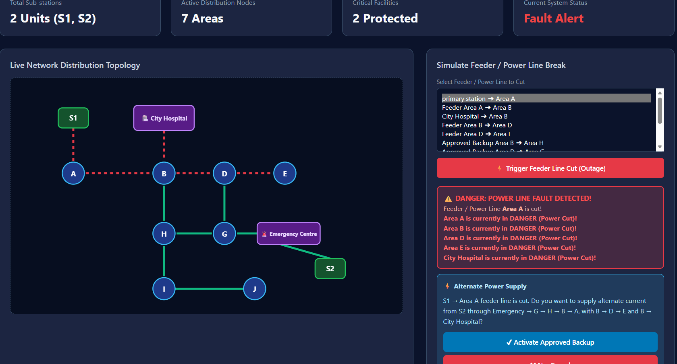
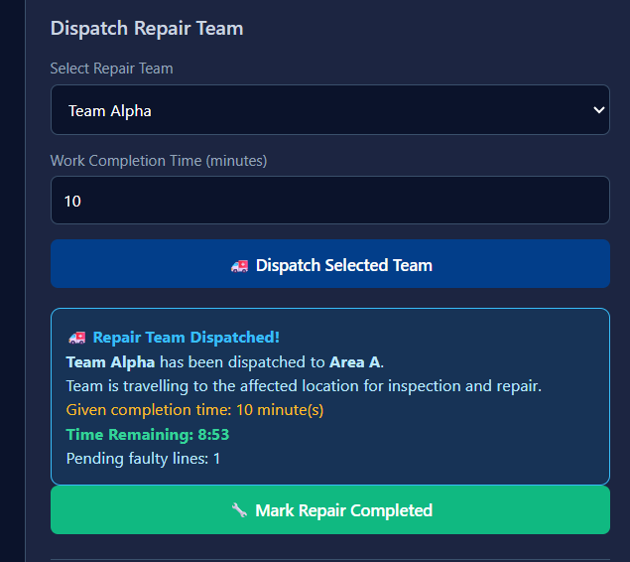
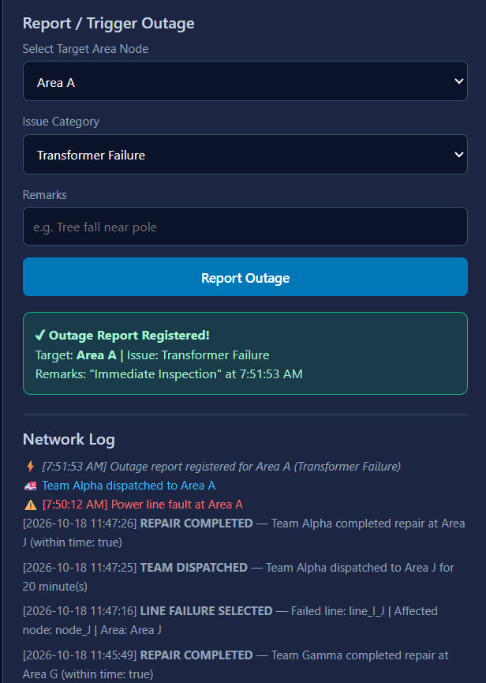

CHAPTER 3

TESTING, RESULTS AND EVALUATION

3.1 Testing and Validation:
The developed traffic management system was functionally validated using normal, boundary, and invalid test cases to verify congestion detection, identification of blocked routes, routing prioritization, alternative path assignment, database updates, and web-interface operations. Testing confirmed that BFS/DFS correctly identifies disconnected or heavily congested road networks, the PriorityQueue prioritizes emergency vehicle routing jobs, alternative routes are assigned successfully, and network connectivity is updated after traffic clearance. The web application also successfully supports traffic incident reporting, network monitoring, and database operations through JDBC. The algorithms provide efficient performance, with BFS/DFS requiring O(V + E) time and O(V) auxiliary space, HashMap and HashSet operations taking O(1) average time, and PriorityQueue operations requiring O(log n) time, making the system highly suitable for the GitHub project's simulated road network.
3.2 Results and Performance Analysis:
The Smart Traffic Detection and Routing System was tested to verify the correctness and efficiency of its major functions. The system successfully recorded traffic fault reports, identified heavily congested areas, prioritized clearing activities, assigned alternative routes, and updated the real-time traffic status. The use of an Adjacency List helped represent the road network connections efficiently, while HashMap and HashSet provided fast data retrieval and tracking of visited nodes during network analysis. The PriorityQueue enabled routing tasks to be processed based on their priority, giving greater importance to critical entities such as ambulances and emergency response vehicles. Database connectivity successfully stored congestion, rerouting, and clearance records, while the web interface provided a simple way to monitor traffic network status and activities. The testing results showed that the system performed its intended operations correctly and provided an organized, programmatic approach to traffic congestion detection and flow management.

3.3 Sustainability, Cost & Resource Efficiency:
The proposed system is designed as a low-cost software solution that can be developed and operated using commonly available hardware, leveraging standard Java build tools like Maven and GitHub for version control. The application mainly requires a computer with a Java runtime environment, a web browser, and a local database, resulting in minimal additional hardware requirements. Since the system performs graph-based traffic analysis on a simulated network, its computational and memory requirements are low. The software does not require high-end GPU hardware or continuous intensive computation, which helps reduce energy consumption during operation. By identifying congested areas quickly and prioritizing critical routes for emergency services, the system can support efficient urban traffic management and reduce transit delays. The project directly supports SDG 9 (Industry, Innovation and Infrastructure), SDG 11 (Sustainable Cities and Communities), and SDG 13 (Climate Action, by reducing vehicle idling emissions) by promoting reliable transport infrastructure, efficient resource management, and improved support for critical community transit services.

3.4 Limitations & Future Enhancements:

Current limitations:
The current system is a simulation of a simplified traffic distribution network and does not represent a complete real-world municipal traffic control system. It supports a limited number of nodes (intersections) and predefined road connections. The system assumes that traffic blockages and estimated clearance times are entered by the operator rather than being obtained automatically from live traffic cameras or GPS sensors. The BFS/DFS analysis determines network connectivity and alternative paths but does not perform complex traffic flow calculations such as vehicle density, acceleration dynamics, or multi-agent collision avoidance. Backup routes are predefined and are used only for connectivity analysis rather than automatically controlling physical traffic lights. Therefore, this GitHub-hosted system serves as a foundational prototype and should not be used directly for real-world municipal traffic operation without additional engineering, safety protocols, and hardware infrastructure integration.
Future Enhancements:

Future enhancements include integrating IoT devices and live traffic cameras for automated, real-time congestion detection. Incorporating machine learning models to predict traffic bottlenecks during peak hours would also improve predictive routing. Finally, scaling the architecture for massive city networks and implementing automated deployment pipelines from the GitHub repository would make the system fully production-ready.

CHAPTER 4

GITHUB AND CONCLUSION

4.1 GitHub Repository & Version Control:

https://github.com/champalal766/traffic.git

4.1.2 Repository Overview & Folder Structure

Repository Overview

The Smart-Electricity-outage-detection-and-restoration-System repository contains the complete source code and supporting files for the electricity outage detection and restoration system. It is organized into main and webpage branches, containing the core Java application and web-based implementation respectively.

Folder Structure:

Smart-Electricity-outage-detection-and-restoration-System/
MP/
├── .github/
│ └── modernize/
│ └── java-upgrade/
│ ├── 20261011140257/
│ │ └── logs/
│ │ └── 0.log
│ ├── hooks/
│ │ └── scripts/
│ │ ├── recordToolUse.ps1
│ │ └── recordToolUse.sh
│ └── .gitignore
├── .tools/
│ └── apache-maven-3.9.15/
│ ├── bin/
│ ├── boot/
│ ├── conf/
│ │ └── logging/
│ └── lib/
│ ├── ext/
│ │ ├── hazelcast/
│ │ └── redisson/
│ └── jansi-native/
│ └── Windows/
│ ├── arm64/
│ ├── x86/
│ └── x86_64/
├── .vscode/
│ ├── settings.json
│ └── tasks.json
├── src/
│ └── main/
│ ├── java/
│ │ └── com/
│ │ └── vegamcity/
│ │ └── traffic/
│ │ ├── DispatchEntity.java
│ │ ├── DispatchRepository.java
│ │ ├── EmergencyVehicleEntity.java
│ │ ├── EmergencyVehicleRepository.java
│ │ ├── RoadEntity.java
│ │ ├── RoadRepository.java
│ │ ├── SmartTrafficApplication.java
│ │ ├── TrafficController.java
│ │ ├── TrafficEventEntity.java
│ │ ├── TrafficEventRepository.java
│ │ └── TrafficService.java
│ └── resources/
│ ├── application.properties
│ └── static/
│ └── index.html
├── target/
│ ├── classes/
│ │ ├── com/
│ │ │ └── vegamcity/
│ │ │ └── traffic/
│ │ └── static/
│ ├── generated-sources/
│ │ └── annotations/
│ ├── maven-archiver/
│ ├── maven-status/
│ │ └── maven-compiler-plugin/
│ │ └── compile/
│ │ └── default-compile/
│ └── smart-traffic-management-1.0.0.jar
├── _Main_.java
├── docker-compose.yml
├── pom.xml
└── README.md
4.1.2 Source Code & Execution Instructions

Summary of source files
The project consists of multiple Java source files, with each class responsible for a specific component of the traffic detection and routing system. Main.java acts as the entry point of the application. TrafficControlCenter.java and RoadSegment.java model the municipal road infrastructure, while Intersection.java and related classes represent different types of transit nodes and consumer areas. TrafficIncidentReport.java manages congestion and collision information, and EmergencyResponseTeam.java handles the dispatch details of clearance units. RoadNetwork.java manages the overall network structure and connectivity analysis, while RoutingPolicy.java implements the priority-based rerouting logic. The project is executed using the Java JDK through a standard IDE or command-line environment, and the web version utilizes a Java backend to provide graphical monitoring and traffic-management features.

Execution Setup

1. Install Java JDK.
2. Clone/download the GitHub repository.
3. Open the project in a Java IDE such as IntelliJ IDEA / Eclipse.
4. Compile the Java source files.
5. Run Main.java.
6. For the web version, start the Java HttpServer backend.
7. Open the provided localhost address in a web browser.
8. Use the dashboard to report faults, monitor affected areas,
assign repair teams, and complete restoration.

README
The Smart Traffic Detection and Routing System is a Java-based web application developed to monitor road network congestion and support efficient traffic flow restoration. The system provides a user-friendly dashboard for reporting traffic blockages, identifying road segment failures, monitoring affected intersections, assigning emergency clearance teams, and tracking routing progress. It is developed using Java (JDK 17 or later), Maven, Java HttpServer, SQLite, and JDBC. The application stores crucial information such as traffic incident reports, blocked routes, emergency dispatch assignments, expected clearance times, resolved incidents, and event history within the SQLite database. The dashboard provides a visual representation of the municipal road network, allowing operators to observe traffic flow status and interact with transit components. A Live Log section displays recorded congestion and clearance events for streamlined monitoring. The project can be opened as a Maven project in environments like IntelliJ IDEA, with JDK 17 or later configured as the project SDK. Upon running Main.java, the Java web server starts locally on port 8080, making the application accessible via http://localhost:8080. Overall, the system integrates congestion reporting, network monitoring, incident management, response team coordination, routing tracking, and persistent database storage into a single cohesive platform, providing a highly practical simulation of modern urban traffic management.
4.2 CONCLUSION
The Smart Traffic Detection and Routing System successfully provides an organized, programmatic approach for detecting traffic congestion, identifying affected road intersections, and managing flow restoration activities. The system represents the transit distribution network using robust graph-based structures such as Adjacency Lists, HashMaps, HashSets, ArrayLists, and PriorityQueues. These data structures are instrumental in efficiently storing network information, identifying blocked routes, tracking visited nodes, maintaining incident records, and prioritizing emergency clearance activities. Graph traversal techniques, specifically Breadth-First Search (BFS), are utilized to analyze the network and accurately determine the interconnected areas impacted by a traffic fault. The PriorityQueue effectively prioritizes rerouting tasks, particularly for critical entities such as ambulances and emergency response vehicles, demonstrating how advanced data structures and algorithms can be applied to solve practical municipal network management problems.
The project also highlights essential Object-Oriented Programming concepts in Java, including encapsulation, inheritance, polymorphism, abstraction, and composition. Different entities such as traffic control centers, road segments, incident reports, response teams, and intersections are represented as distinct objects, ensuring the system remains modular and maintainable. Database connectivity through JDBC provides persistent storage for all network details, fault reports, team dispatch information, and routing records, while the web-based interface delivers a user-friendly environment for monitoring network status and clearance progress. Overall, the project demonstrates the practical application of Java, Data Structures, Graph Algorithms, Object-Oriented Programming, and Database Connectivity in addressing a real-world traffic management problem. Although developed as an academic simulation, the system establishes a strong foundation for focused future enhancements like IoT sensor integration and predictive bottleneck modeling, underscoring the critical role of technology in building reliable, efficient, and sustainable urban transport infrastructure.
.

4.1.3 Commit History & Evidence

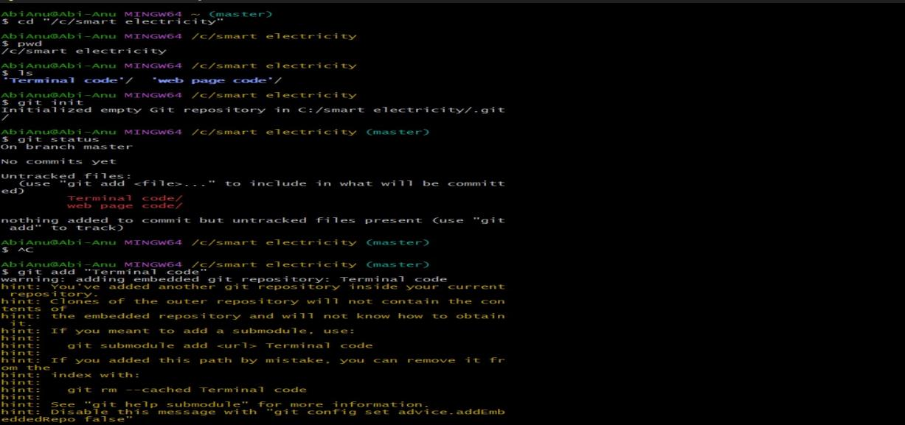

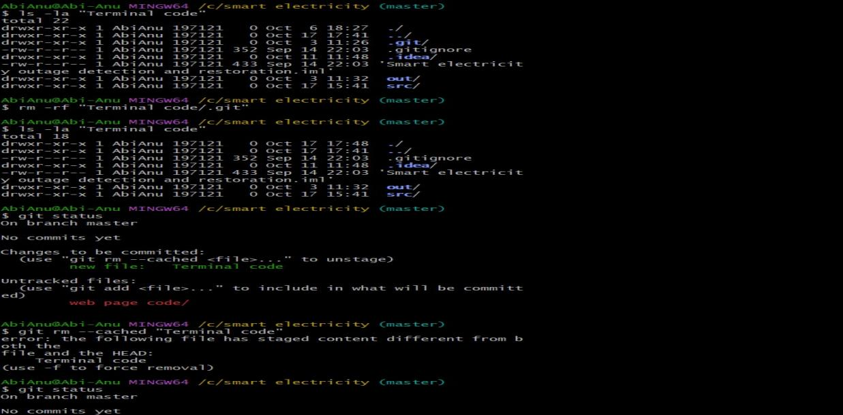

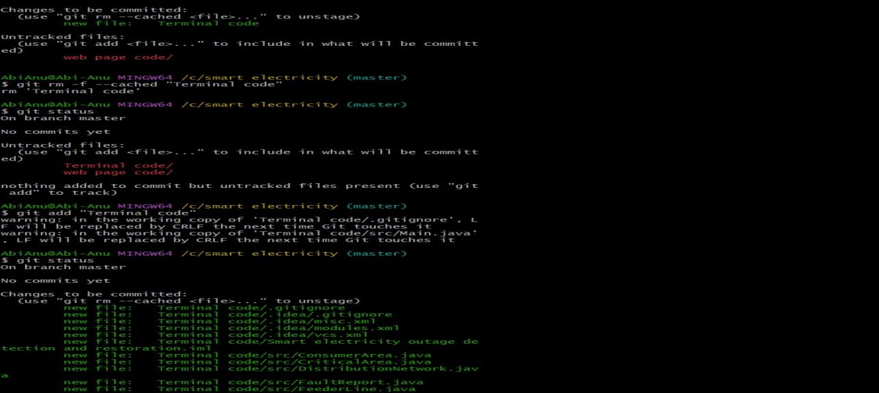
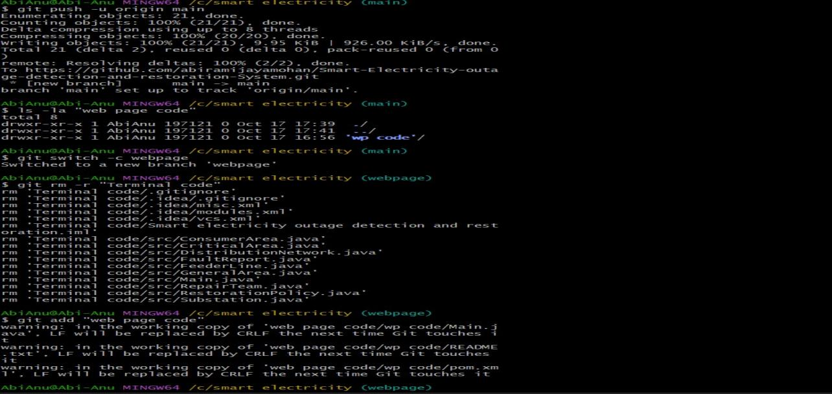

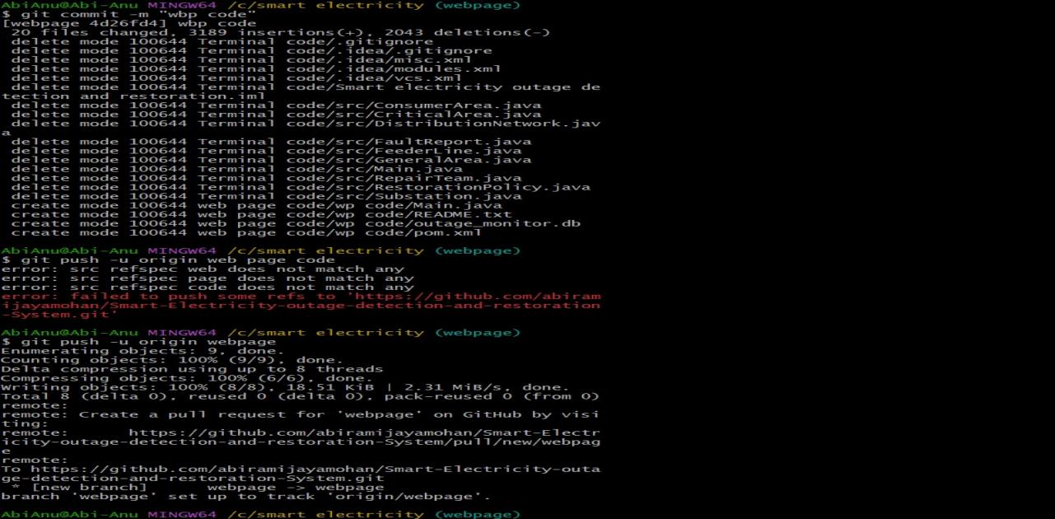

.

4.2 CONCLUSION

The Smart Traffic Detection and Routing System successfully provides an organized, programmatic approach for detecting traffic congestion, identifying affected road intersections, and managing flow restoration activities. The system represents the transit distribution network using robust graph-based structures such as Adjacency Lists, HashMaps, HashSets, ArrayLists, and PriorityQueues. These data structures are instrumental in efficiently storing network information, identifying blocked routes, tracking visited nodes, maintaining incident records, and prioritizing emergency clearance activities. Graph traversal techniques, specifically Breadth-First Search (BFS), are utilized to analyze the network and accurately determine the interconnected areas impacted by a traffic fault. The PriorityQueue effectively prioritizes rerouting tasks, particularly for critical entities such as ambulances and emergency response vehicles, demonstrating how advanced data structures and algorithms can be applied to solve practical municipal network management problems.
The project also highlights essential Object-Oriented Programming concepts in Java, including encapsulation, inheritance, polymorphism, abstraction, and composition. Different entities such as traffic control centers, road segments, incident reports, response teams, and intersections are represented as distinct objects, ensuring the system remains modular and maintainable. Database connectivity through JDBC provides persistent storage for all network details, fault reports, team dispatch information, and routing records, while the web-based interface delivers a user-friendly environment for monitoring network status and clearance progress. Overall, the project demonstrates the practical application of Java, Data Structures, Graph Algorithms, Object-Oriented Programming, and Database Connectivity in addressing a real-world traffic management problem. Although developed as an academic simulation, the system establishes a strong foundation for focused future enhancements like IoT sensor integration and predictive bottleneck modeling, underscoring the critical role of technology in building reliable, efficient, and sustainable urban transport infrastructure.

REFERENCES

1. Oracle Corporation. (2024). Java Platform, Standard Edition Documentation. Retrieved from https://docs.oracle.com/en/java/

2. Oracle Corporation. (2024). JDBC Database Access – Java Tutorials. Retrieved from https://docs.oracle.com/javase/tutorial/jdbc/

3. Oracle Corporation. (2024). Java Collections Framework Documentation. Retrieved from https://docs.oracle.com/en/java/javase/

4 Oracle Corporation. (2024). Java Networking and HTTP Server Documentation. Retrieved from https://docs.oracle.com/en/java/javase/

5 SQLite. (2026). SQLite Documentation. Retrieved from https://www.sqlite.org/docs.html

6 SQLite. (2026). SQLite SQL Language Documentation. Retrieved from https://www.sqlite.org/lang.html

7 GeeksforGeeks. (2025). Java Program for Breadth First Search (BFS) for a Graph. Retrieved from https://www.geeksforgeeks.org/java/java-program-for-breadth-first-search-or-bfs-for-a-graph/

8 GeeksforGeeks. (2025). Graph Data Structure and Algorithms. Retrieved from https://www.geeksforgeeks.org/dsa/graph-data-structure-and-algorithms/

9 GeeksforGeeks. (2025). Priority Queue in Java. Retrieved from https://www.geeksforgeeks.org/java/priority-queue-in-java/

10 GeeksforGeeks. (2025). HashMap in Java. Retrieved from https://www.geeksforgeeks.org/java/hashmap-in-java/

APPENDIX (CODE)

import com.sun.net.httpserver.HttpServer;
import java.io.IOException;
import java.io.OutputStream;
import java.net.InetSocketAddress;
import java.net.URLDecoder;
import java.nio.charset.StandardCharsets;
import java.sql.Connection;
import java.sql.DriverManager;
import java.sql.PreparedStatement;
import java.sql.ResultSet;
import java.sql.SQLException;
import java.sql.Statement;
import java.time.LocalDateTime;
import java.time.format.DateTimeFormatter;
import java.util.LinkedHashMap;
import java.util.Map;
public class Main {
public static void main(String[] args) throws IOException {
HttpServer server =
HttpServer.create(new InetSocketAddress(8080), 0);
server.createContext("/", exchange -> {
String html = buildHtml();
byte[] bytes =
html.getBytes(StandardCharsets.UTF_8);
exchange.getResponseHeaders()
.set(
"Content-Type",
"text/html; charset=UTF-8"
);
exchange.sendResponseHeaders(
200,
bytes.length
);
try (OutputStream os =
exchange.getResponseBody()) {
os.write(bytes);
}
});
Database.initialize();
server.createContext("/api/report", exchange -> {
try {
Map<String, String> data = readForm(exchange);
long id = Database.createOutage(
data.getOrDefault("node", "Unknown area"),
data.getOrDefault("issue", "Unspecified issue"),
data.getOrDefault("remarks", ""),
"", "", data.getOrDefault("node", "Unknown area"),
null, "");
sendJson(exchange, 200, "{\"success\":true,\"id\":" + id + "}");
} catch (Exception e) { e.printStackTrace(); sendJson(exchange, 500, "{\"success\":false}"); }
});
server.createContext("/api/fault", exchange -> {
try {
Map<String, String> data = readForm(exchange);
String lineId = data.getOrDefault("lineId", "");
String nodeId = data.getOrDefault("nodeId", "");
String area = data.getOrDefault("area", "Unknown area");
long id = Database.createOutage(
area,
"Feeder Line Failure", "Triggered from network map",
lineId, nodeId, area,
"LINE_FAILURE_SELECTED",
"Failed line: " + lineId + " | Affected node: " + nodeId + " | Area: " + area);
sendJson(exchange, 200, "{\"success\":true,\"id\":" + id + "}");
} catch (Exception e) { e.printStackTrace(); sendJson(exchange, 500, "{\"success\":false}"); }
});
server.createContext("/api/dispatch", exchange -> {
try {
Map<String, String> data = readForm(exchange);
Database.dispatch(
data.getOrDefault("lineId", ""),
data.getOrDefault("team", "Unknown team"),
data.getOrDefault("area", "Unknown area"),
data.getOrDefault("completionMinutes", "0"));
sendJson(exchange, 200, "{\"success\":true}");
} catch (Exception e) { e.printStackTrace(); sendJson(exchange, 500, "{\"success\":false}"); }
});
server.createContext("/api/complete", exchange -> {
try {
Map<String, String> data = readForm(exchange);
Database.complete(
data.getOrDefault("lineId", ""),
data.getOrDefault("team", "Unknown team"),
data.getOrDefault("area", "Unknown area"),
data.getOrDefault("completedWithinTime", "false"));
sendJson(exchange, 200, "{\"success\":true}");
} catch (Exception e) { e.printStackTrace(); sendJson(exchange, 500, "{\"success\":false}"); }
});
server.createContext("/api/history", exchange -> {
try { sendJson(exchange, 200, Database.historyJson()); }
catch (Exception e) { e.printStackTrace(); sendJson(exchange, 500, "[]"); }
});
server.setExecutor(null);
server.start();
System.out.println(
"=================================================="
);
System.out.println(
" WEB APPLICATION DASHBOARD STARTED "
);
System.out.println(
" URL: http:
);
System.out.println(
"=================================================="
);
}
private static Map<String, String> readForm(com.sun.net.httpserver.HttpExchange exchange) throws IOException {
String body;
try (var input = exchange.getRequestBody()) {
body = new String(input.readAllBytes(), StandardCharsets.UTF_8);
}
Map<String, String> values = new LinkedHashMap<>();
if (!body.isBlank()) {
for (String pair : body.split("&")) {
String[] parts = pair.split("=", 2);
String key = URLDecoder.decode(parts[0], StandardCharsets.UTF_8);
String value = parts.length > 1
? URLDecoder.decode(parts[1], StandardCharsets.UTF_8) : "";
values.put(key, value);
}
}
return values;
}
private static void sendJson(com.sun.net.httpserver.HttpExchange exchange, int status, String json) throws IOException {
byte[] bytes = json.getBytes(StandardCharsets.UTF_8);
exchange.getResponseHeaders().set("Content-Type", "application/json; charset=UTF-8");
exchange.getResponseHeaders().set("Access-Control-Allow-Origin", "*");
exchange.sendResponseHeaders(status, bytes.length);
try (OutputStream out = exchange.getResponseBody()) { out.write(bytes); }
}
private static final class Database {
private static final String URL = "jdbc:sqlite:outage_monitor.db";
private static final DateTimeFormatter TIME = DateTimeFormatter.ofPattern("yyyy-MM-dd HH:mm:ss");
static Connection connect() throws SQLException { return DriverManager.getConnection(URL); }
static void initialize() {
try {
Class.forName("org.sqlite.JDBC");
try (Connection c = connect(); Statement st = c.createStatement()) {
st.executeUpdate("CREATE TABLE IF NOT EXISTS outages (" +
"id INTEGER PRIMARY KEY AUTOINCREMENT, target TEXT NOT NULL, issue TEXT NOT NULL, remarks TEXT, " +
"line_id TEXT, node_id TEXT, area TEXT, team TEXT, completion_minutes INTEGER DEFAULT 0, " +
"status TEXT NOT NULL DEFAULT 'OPEN', created_at TEXT NOT NULL, dispatched_at TEXT, completed_at TEXT, " +
"completed_within_time TEXT)");
st.executeUpdate("CREATE TABLE IF NOT EXISTS event_history (" +
"id INTEGER PRIMARY KEY AUTOINCREMENT, outage_id INTEGER, event_type TEXT NOT NULL, " +
"details TEXT NOT NULL, event_time TEXT NOT NULL)");
}
System.out.println("SQLite connected: outage_monitor.db");
} catch (Exception e) {
throw new IllegalStateException("SQLite driver/database setup failed. Add sqlite-jdbc dependency in pom.xml.", e);
}
}
static String now() { return LocalDateTime.now().format(TIME); }
static long createOutage(String target, String issue, String remarks, String lineId, String nodeId, String area,
String eventType, String eventDetails) throws SQLException {
try (Connection c = connect(); PreparedStatement ps = c.prepareStatement(
"INSERT INTO outages(target,issue,remarks,line_id,node_id,area,status,created_at) VALUES(?,?,?,?,?,?, 'OPEN',?)",
Statement.RETURN_GENERATED_KEYS)) {
ps.setString(1, target); ps.setString(2, issue); ps.setString(3, remarks);
ps.setString(4, lineId); ps.setString(5, nodeId); ps.setString(6, area); ps.setString(7, now());
ps.executeUpdate();
long id;
try (ResultSet rs = ps.getGeneratedKeys()) { id = rs.next() ? rs.getLong(1) : 0; }
if (eventType != null && !eventType.isBlank()) {
event(c, id, eventType, eventDetails);
}
return id;
}
}
static void dispatch(String lineId, String team, String area, String minutes) throws SQLException {
try (Connection c = connect()) {
long id = latestOpenId(c, lineId);
if (id != 0) {
try (PreparedStatement ps = c.prepareStatement("UPDATE outages SET team=?, completion_minutes=?, status='DISPATCHED', dispatched_at=? WHERE id=?")) {
ps.setString(1, team); ps.setInt(2, parseInt(minutes)); ps.setString(3, now()); ps.setLong(4, id); ps.executeUpdate();
}
}
event(c, id == 0 ? null : id, "TEAM_DISPATCHED", team + " dispatched to " + area + " for " + minutes + " minute(s)");
}
}
static void complete(String lineId, String team, String area, String withinTime) throws SQLException {
try (Connection c = connect()) {
long id = latestDispatchedId(c, lineId);
if (id != 0) {
try (PreparedStatement ps = c.prepareStatement("UPDATE outages SET status='COMPLETED', completed_at=?, completed_within_time=? WHERE id=?")) {
ps.setString(1, now()); ps.setString(2, withinTime); ps.setLong(3, id); ps.executeUpdate();
}
}
event(c, id == 0 ? null : id, "REPAIR_COMPLETED", team + " completed repair at " + area + " (within time: " + withinTime + ")");
}
}
private static int parseInt(String value) { try { return Integer.parseInt(value); } catch (Exception e) { return 0; } }
private static long latestOpenId(Connection c, String lineId) throws SQLException {
try (PreparedStatement ps = c.prepareStatement("SELECT id FROM outages WHERE line_id=? AND status='OPEN' ORDER BY id DESC LIMIT 1")) {
ps.setString(1, lineId); try (ResultSet rs = ps.executeQuery()) { return rs.next() ? rs.getLong(1) : 0; }
}
}
private static long latestDispatchedId(Connection c, String lineId) throws SQLException {
try (PreparedStatement ps = c.prepareStatement("SELECT id FROM outages WHERE line_id=? AND status='DISPATCHED' ORDER BY id DESC LIMIT 1")) {
ps.setString(1, lineId); try (ResultSet rs = ps.executeQuery()) { return rs.next() ? rs.getLong(1) : 0; }
}
}
private static void event(Connection c, Long outageId, String type, String details) throws SQLException {
try (PreparedStatement ps = c.prepareStatement("INSERT INTO event_history(outage_id,event_type,details,event_time) VALUES(?,?,?,?)")) {
if (outageId == null) ps.setNull(1, java.sql.Types.INTEGER); else ps.setLong(1, outageId);
ps.setString(2, type); ps.setString(3, details); ps.setString(4, now()); ps.executeUpdate();
}
}
static String historyJson() throws SQLException {
StringBuilder out = new StringBuilder("[");
try (Connection c = connect(); Statement st = c.createStatement();
ResultSet rs = st.executeQuery("SELECT event_type,details,event_time FROM event_history ORDER BY id DESC LIMIT 100")) {
boolean first = true;
while (rs.next()) {
if (!first) out.append(','); first = false;
out.append("{\"type\":\"").append(jsonEscape(rs.getString(1)))
.append("\",\"details\":\"").append(jsonEscape(rs.getString(2)))
.append("\",\"time\":\"").append(jsonEscape(rs.getString(3))).append("\"}");
}
}
return out.append(']').toString();
}
private static String jsonEscape(String s) {
if (s == null) return "";
return s.replace("\\", "\\\\").replace("\"", "\\\"")
.replace("\n", "\\n").replace("\r", "\\r");
}
}
private static String buildHtml() {
StringBuilder html =
new StringBuilder(120000);
html.append("""
<!DOCTYPE html>
<html lang="en">
<head>
<meta charset="UTF-8">
<meta name="viewport" content="width=device-width, initial-scale=1.0">
<title>Smart Electricity Outage Monitoring System</title>
<style>
* {
box-sizing: border-box;
margin: 0;
padding: 0;
font-family: 'Segoe UI', Tahoma, Geneva, Verdana, sans-serif;
}
body {
background-color: #0b132b;
color: #f8fafc;
}
.navbar {
background: #1c2541;
padding: 16px 30px;
display: flex;
justify-content: space-between;
align-items: center;
border-bottom: 1px solid #3a506b;
}
.navbar h1 {
font-size: 20px;
color: #48cae4;
display: flex;
align-items: center;
gap: 10px;
}
.status-badge {
background: #10b981;
color: white;
padding: 5px 12px;
border-radius: 20px;
font-size: 12px;
font-weight: 600;
}
.main-container {
padding: 25px 30px;
max-width: 1400px;
margin: 0 auto;
}
.metrics-grid {
display: grid;
grid-template-columns: repeat(4, 1fr);
gap: 20px;
margin-bottom: 25px;
}
.metric-card {
background: #1c2541;
padding: 20px;
border-radius: 12px;
border: 1px solid #3a506b;
}
.metric-card p {
font-size: 13px;
color: #94a3b8;
margin-bottom: 6px;
}
.metric-card h3 {
font-size: 24px;
color: #f8fafc;
}
.content-grid {
display: grid;
grid-template-columns: 2fr 1.2fr;
gap: 25px;
}
.card {
background: #1c2541;
border-radius: 12px;
padding: 20px;
border: 1px solid #3a506b;
}
.card-title {
font-size: 16px;
font-weight: 600;
color: #cbd5e1;
margin-bottom: 15px;
display: flex;
justify-content: space-between;
align-items: center;
}
.network-box {
background: #070e20;
border-radius: 10px;
border: 1px dashed #3a506b;
padding: 10px;
display: flex;
justify-content: center;
overflow: hidden;
}
.form-group {
margin-bottom: 12px;
}
.form-group label {
display: block;
font-size: 12px;
color: #94a3b8;
margin-bottom: 5px;
}
.form-group select,
.form-group input {
width: 100%;
padding: 10px;
border-radius: 6px;
border: 1px solid #3a506b;
background: #0b132b;
color: white;
font-size: 13px;
}
.btn-danger,
.btn-submit,
.btn-repair {
width: 100%;
color: white;
padding: 11px;
border: none;
border-radius: 6px;
font-weight: 600;
cursor: pointer;
transition: 0.2s;
margin-bottom: 6px;
}
.btn-danger {
background: #e63946;
}
.btn-danger:hover {
background: #d62828;
}
.btn-submit {
background: #0077b6;
}
.btn-submit:hover {
background: #023e8a;
}
.btn-repair {
background: #10b981;
display: none;
}
.btn-repair:hover {
background: #059669;
}
#dangerAlert,
#dispatchAlert,
#repairSuccessAlert {
display: none;
margin-top: 10px;
padding: 12px;
border-radius: 8px;
font-size: 13px;
line-height: 1.5;
animation: fadeIn 0.3s ease-in-out;
}
#dangerAlert {
background: rgba(230, 57, 70, 0.2);
border: 2px solid #e63946;
color: #ffb4a2;
}
#dispatchAlert {
background: rgba(0, 119, 182, 0.18);
border: 1px solid #38bdf8;
color: #bae6fd;
}
#repairSuccessAlert {
background: rgba(16, 185, 129, 0.15);
border: 2px solid #10b981;
color: #a7f3d0;
}
@keyframes fadeIn {
from {
opacity: 0;
transform: translateY(-5px);
}
to {
opacity: 1;
transform: translateY(0);
}
}
.line-cut {
stroke: #e63946 !important;
stroke-dasharray: 6 !important;
animation: blink 1s infinite alternate;
}
.node-danger {
fill: #991b1b !important;
stroke: #ef4444 !important;
}
@keyframes blink {
from {
opacity: 0.4;
}
to {
opacity: 1;
}
}
.table-container {
margin-top: 25px;
}
table {
width: 100%;
border-collapse: collapse;
text-align: left;
font-size: 13px;
margin-top: 10px;
}
th {
background: #0b132b;
padding: 12px;
color: #94a3b8;
font-weight: 600;
border-bottom: 1px solid #3a506b;
}
td {
padding: 12px;
border-bottom: 1px solid #3a506b;
color: #cbd5e1;
}
.badge-ok {
color: #34d399;
font-weight: 600;
}
.badge-offline {
color: #f87171;
font-weight: 600;
}
.alternate-line {
stroke: #38bdf8 !important;
stroke-width: 6 !important;
stroke-dasharray: 10 5;
animation: alternateFlow 0.8s linear infinite;
}
.power-safe {
stroke: #38bdf8 !important;
stroke-width: 5 !important;
stroke-dasharray: none !important;
animation: none !important;
}
@keyframes alternateFlow {
to {
stroke-dashoffset: -15;
}
}
#alternateAlert {
display: none;
background: rgba(56, 189, 248, 0.15);
border: 1px solid #38bdf8;
color: #bae6fd;
padding: 12px;
margin-top: 10px;
border-radius: 8px;
line-height: 1.6;
font-size: 13px;
}
</style>
</head>
<body>
<div class="navbar">
<h1>⚡ SMART ELECTRICITY OUTAGE MONITOR</h1>
<span class="status-badge" id="gridStatus">
● Grid Online
</span>
</div>
<div class="main-container">
<div class="metrics-grid">
<div class="metric-card">
<p>Total Sub-stations</p>
<h3>2 Units (S1, S2)</h3>
</div>
<div class="metric-card">
<p>Active Distribution Nodes</p>
<h3 id="activeAreas">8 Areas</h3>
</div>
<div class="metric-card">
<p>Critical Facilities</p>
<h3 id="criticalFacilities">2 Protected</h3>
</div>
<div class="metric-card">
<p>Current System Status</p>
<h3 id="systemHealthText"
style="color: #34d399;">
Healthy
</h3>
</div>
</div>
<div class="content-grid">
<div class="card">
<div class="card-title">
<span>
Live Network Distribution Topology
</span>
</div>
<div class="network-box">
<svg width="100%"
height="450"
viewBox="0 0 650 450">
<!-- Feeder / Power Lines -->
<line id="line_S1_A"
x1="60" y1="90"
x2="60" y2="160"
stroke="#10b981"
stroke-width="4" />
<line id="line_A_B"
x1="85" y1="180"
x2="215" y2="180"
stroke="#10b981"
stroke-width="4" />
<line id="line_Hosp_B"
x1="240" y1="95"
x2="240" y2="155"
stroke="#10b981"
stroke-width="4" />
<line id="line_B_D"
x1="265" y1="180"
x2="335" y2="180"
stroke="#10b981"
stroke-width="4" />
<line id="line_D_E"
x1="385" y1="180"
x2="455" y2="180"
stroke="#10b981"
stroke-width="4" />
<line id="line_B_H"
x1="240" y1="205"
x2="240" y2="275"
stroke="#10b981"
stroke-width="4" />
<line id="line_D_G"
x1="360" y1="205"
x2="360" y2="275"
stroke="#10b981"
stroke-width="4" />
<line id="line_H_G"
x1="265" y1="300"
x2="335" y2="300"
stroke="#10b981"
stroke-width="4" />
<line id="line_H_I"
x1="240" y1="325"
x2="240" y2="385"
stroke="#10b981"
stroke-width="4" />
<line id="line_I_J"
x1="262" y1="410"
x2="398" y2="410"
stroke="#10b981"
stroke-width="4" />
<line id="line_G_Emerg"
x1="385" y1="300"
x2="425" y2="300"
stroke="#10b981"
stroke-width="4" />
<line id="line_Emerg_S2"
x1="472" y1="322"
x2="570" y2="350"
stroke="#10b981"
stroke-width="4" />
<!-- Substation S1 -->
<rect x="30" y="50"
width="60"
height="40"
rx="8"
fill="#14532d"
stroke="#22c55e"
stroke-width="2"/>
<text x="60" y="75"
fill="#f8fafc"
font-size="14"
font-weight="bold"
text-anchor="middle">
S1
</text>
<!-- City Hospital -->
<rect id="node_Hospital" x="180" y="45"
width="120"
height="50"
rx="8"
fill="#581c87"
stroke="#c084fc"
stroke-width="2"/>
<text x="240" y="75"
fill="#e9d5ff"
font-size="12"
font-weight="bold"
text-anchor="middle">
🏥 City Hospital
</text>
<!-- Emergency Centre -->
<rect x="425" y="278"
width="125"
height="44"
rx="8"
fill="#581c87"
stroke="#c084fc"
stroke-width="2"/>
<text x="487.5" y="305"
fill="#e9d5ff"
font-size="11"
font-weight="bold"
text-anchor="middle">
🚨 Emergency Centre
</text>
<!-- Substation S2 -->
<rect x="540" y="350"
width="60"
height="40"
rx="8"
fill="#14532d"
stroke="#22c55e"
stroke-width="2"/>
<text x="570" y="375"
fill="#f8fafc"
font-size="14"
font-weight="bold"
text-anchor="middle">
S2
</text>
<!-- Nodes -->
<circle id="node_A"
cx="60" cy="180"
r="22"
fill="#1e3a8a"
stroke="#38bdf8"
stroke-width="2"/>
<text x="60" y="186"
fill="white"
font-weight="bold"
font-size="14"
text-anchor="middle">
A
</text>
<circle id="node_B"
cx="240" cy="180"
r="22"
fill="#1e3a8a"
stroke="#38bdf8"
stroke-width="2"/>
<text x="240" y="186"
fill="white"
font-weight="bold"
font-size="14"
text-anchor="middle">
B
</text>
<circle id="node_D"
cx="360" cy="180"
r="22"
fill="#1e3a8a"
stroke="#38bdf8"
stroke-width="2"/>
<text x="360" y="186"
fill="white"
font-weight="bold"
font-size="14"
text-anchor="middle">
D
</text>
<circle id="node_E"
cx="480" cy="180"
r="22"
fill="#1e3a8a"
stroke="#38bdf8"
stroke-width="2"/>
<text x="480" y="186"
fill="white"
font-weight="bold"
font-size="14"
text-anchor="middle">
E
</text>
<circle id="node_H"
cx="240" cy="300"
r="22"
fill="#1e3a8a"
stroke="#38bdf8"
stroke-width="2"/>
<text x="240" y="306"
fill="white"
font-weight="bold"
font-size="14"
text-anchor="middle">
H
</text>
<circle id="node_G"
cx="360" cy="300"
r="22"
fill="#1e3a8a"
stroke="#38bdf8"
stroke-width="2"/>
<text x="360" y="306"
fill="white"
font-weight="bold"
font-size="14"
text-anchor="middle">
G
</text>
<circle id="node_I"
cx="240" cy="410"
r="22"
fill="#1e3a8a"
stroke="#38bdf8"
stroke-width="2"/>
<text x="240" y="416"
fill="white"
font-weight="bold"
font-size="14"
text-anchor="middle">
I
</text>
<circle id="node_J"
cx="420" cy="410"
r="22"
fill="#1e3a8a"
stroke="#38bdf8"
stroke-width="2"/>
<text x="420" y="416"
fill="white"
font-weight="bold"
font-size="14"
text-anchor="middle">
J
</text>
</svg>
</div>
</div>
""");
html.append("""
<div class="card">
<div class="card-title">
Simulate Feeder / Power Line Break
</div>
<div class="form-group">
<label>
Select Feeder / Power Line to Cut
</label>
<select id="lineSelect"
multiple
size="6"
title="Select one or more lines (use Ctrl to select multiple)">
<option value="line_S1_A|node_A|Area A">
primary station ➔ Area A
</option>
<option value="line_A_B|node_B|Area B">
Feeder Area A ➔ Area B
</option>
<option value="line_Hosp_B|node_B|City Hospital">
City Hospital ➔ Area B
</option>
<option value="line_B_D|node_D|Area D">
Feeder Area B ➔ Area D
</option>
<option value="line_D_E|node_E|Area E">
Feeder Area D ➔ Area E
</option>
<option value="line_B_H|node_H|Area H">
Approved Backup Area B ➔ Area H
</option>
<option value="line_D_G|node_G|Area G">
Approved Backup Area D ➔ Area G
</option>
<option value="line_H_I|node_I|Area I">
Feeder Area H ➔ Area I
</option>
<option value="line_I_J|node_J|Area J">
Feeder Area I ➔ Area J
</option>
<option value="line_G_Emerg|node_G|Emergency Centre">
Emergency Centre Feeder ➔ Node G
</option>
<option value="line_Emerg_S2|node_G|Substation S2">
s2 ➔ Emergency Centre
</option>
</select>
</div>
<button type="button"
class="btn-danger"
onclick="triggerLineCut()">
⚡ Trigger Feeder Line Cut (Outage)
</button>
<div id="dangerAlert">
<strong style="color: #ff4d4d; font-size: 14px;">
⚠️ DANGER: POWER LINE FAULT DETECTED!
</strong>
<br>
<span id="dangerMessage"></span>
</div>
<div id="alternateAlert">
<strong>⚡ Alternate Power Supply</strong>
<p id="alternateMessage"
style="margin: 8px 0 12px;">
</p>
<button type="button"
class="btn-submit"
onclick="connectAlternateLine()">
✔ Activate Approved Backup
</button>
<button type="button"
class="btn-danger"
onclick="cancelAlternateLine()">
✖ No, Cancel
</button>
</div>
<div style="margin: 20px 0;
border-top: 1px solid #3a506b;">
</div>
<div class="card-title">
Dispatch Repair Team
</div>
<div class="form-group">
<label>Select Repair Team</label>
<select id="repairTeam">
<option value="Team Alpha">
Team Alpha
</option>
<option value="Team Beta">
Team Beta
</option>
<option value="Team Gamma">
Team Gamma
</option>
</select>
</div>
<div class="form-group">
<label>
Work Completion Time (minutes)
</label>
<input type="number"
id="completionTime"
min="1"
placeholder="Enter time in minutes">
</div>
<button type="button"
class="btn-submit"
onclick="dispatchRepairTeam()">
🚑 Dispatch Selected Team
</button>
<div id="dispatchAlert">
<strong style="color: #38bdf8;">
🚑 Repair Team Dispatched!
</strong>
<br>
<span id="dispatchDetails"></span>
</div>
<button type="button"
id="completeRepairBtn"
class="btn-repair"
onclick="completeRepair()">
🔧 Mark Repair Completed
</button>
<div id="repairSuccessAlert">
<strong style="color: #34d399; font-size: 14px;">
✔ REPAIR COMPLETED SUCCESSFULLY!
</strong>
<br>
<span id="repairSuccessDetails"></span>
</div>
<div style="margin-top: 20px;
border-top: 1px solid #3a506b;
padding-top: 12px;">
<div class="card-title"
style="margin-bottom: 8px;">
Report / Trigger Outage
</div>
<form id="outageForm"
onsubmit="handleDispatch(event)">
<div class="form-group">
<label>
Select Target Area Node
</label>
<select id="targetNode">
<option value="Area A">
Area A
</option>
<option value="Area B">
Area B
</option>
<option value="City Hospital">
City Hospital
</option>
<option value="Area D">
Area D
</option>
<option value="Area E">
Area E
</option>
<option value="Area G">
Area G
</option>
<option value="Area H">
Area H
</option>
<option value="Area I">
Area I
</option>
<option value="Area J">
Area J
</option>
<option value="Emergency Centre">
Emergency Centre
</option>
<option value="Substation S2">
Substation S2
</option>
</select>
</div>
<div class="form-group">
<label>
Issue Category
</label>
<select id="issueType">
<option value="Transformer Failure">
Transformer Failure
</option>
<option value="Feeder Line Failure">
Feeder Line Failure
</option>
<option value="Line Maintenance">
Line Maintenance
</option>
<option value="Voltage Fluctuation">
Voltage Fluctuation
</option>
</select>
</div>
<div class="form-group">
<label>Remarks</label>
<input type="text"
id="remarks"
placeholder="e.g. Tree fall near pole">
</div>
<button type="submit"
class="btn-submit">
Report Outage
</button>
</form>
</div>
<div id="dispatchReportAlert"
style="display:none;
margin-top:10px;
padding:12px;
background:rgba(16,185,129,0.15);
border:1px solid #10b981;
border-radius:8px;
color:#a7f3d0;
font-size:13px;
line-height:1.5;">
<strong>
✔ Outage Report Registered!
</strong>
<br>
<span id="alertDetails"></span>
</div>
<div style="margin-top: 20px;
border-top: 1px solid #3a506b;
padding-top: 12px;">
<div class="card-title"
style="margin-bottom: 8px;">
Network Log
</div>
<p id="liveLog"
style="font-size: 12px;
color: #94a3b8;
line-height: 1.6;">
✔ Substation S1 connected to Node A
<br>
✔ Emergency Centre connected to Node G
<br>
✔ Substation S2 connected to Emergency Centre
<br>
✔ Node I connected to Node J
<br>
✔ Hospital power line isolated & secure
</p>
</div>
</div>
</div>
""");
html.append("""
<div class="card table-container">
<div class="card-title">
Live Node Telemetry Status
</div>
<table>
<thead>
<tr>
<th>Node ID</th>
<th>Feed Type</th>
<th>Linked Connections</th>
<th>Load (%)</th>
<th>Current Status</th>
</tr>
</thead>
<tbody>
<tr>
<td>
<strong>Node B</strong>
</td>
<td>
Primary Hub
</td>
<td>
Area A, City Hospital, Area D, Area H
</td>
<td>
74%
</td>
<td>
<span class="badge-ok">
● Operational
</span>
</td>
</tr>
<tr>
<td>
<strong>Node G</strong>
</td>
<td>
Distributor
</td>
<td>
Emergency Centre, Area H, Area D
</td>
<td>
61%
</td>
<td>
<span class="badge-ok">
● Operational
</span>
</td>
</tr>
<tr>
<td>
<strong>Node I</strong>
</td>
<td>
End Terminal
</td>
<td>
Area H, Area J
</td>
<td>
42%
</td>
<td>
<span class="badge-ok">
● Operational
</span>
</td>
</tr>
<tr>
<td>
<strong>Node J</strong>
</td>
<td>
End Terminal
</td>
<td>
Area I
</td>
<td>
35%
</td>
<td>
<span class="badge-ok">
● Operational
</span>
</td>
</tr>
</tbody>
</table>
</div>
</div>
<script>
""");
html.append("""
let selectedLineId = null;
let selectedNodeId = null;
let affectedArea = null;
let repairTeamDispatched = false;
let activeAreas = 8;
let cutLines = new Set();
let criticalFacilities = 2;
let repairDeadline = null;
let repairTimer = null;
let pendingFaults = [];
let alternateTarget = null;
let alternateRoute = [];
const networkGraph = {
S1: [
{ node: 'A', line: 'line_S1_A' }
],
A: [
{ node: 'S1', line: 'line_S1_A' },
{ node: 'B', line: 'line_A_B' }
],
B: [
{ node: 'A', line: 'line_A_B' },
{ node: 'D', line: 'line_B_D' },
{ node: 'H', line: 'line_B_H' },
{ node: 'Hospital', line: 'line_Hosp_B' }
],
Hospital: [
{ node: 'B', line: 'line_Hosp_B' }
],
D: [
{ node: 'B', line: 'line_B_D' },
{ node: 'E', line: 'line_D_E' },
{ node: 'G', line: 'line_D_G' }
],
E: [
{ node: 'D', line: 'line_D_E' }
],
H: [
{ node: 'B', line: 'line_B_H' },
{ node: 'G', line: 'line_H_G' },
{ node: 'I', line: 'line_H_I' }
],
G: [
{ node: 'D', line: 'line_D_G' },
{ node: 'H', line: 'line_H_G' },
{ node: 'Emergency', line: 'line_G_Emerg' }
],
I: [
{ node: 'H', line: 'line_H_I' },
{ node: 'J', line: 'line_I_J' }
],
J: [
{ node: 'I', line: 'line_I_J' }
],
Emergency: [
{ node: 'G', line: 'line_G_Emerg' },
{ node: 'S2', line: 'line_Emerg_S2' }
],
S2: [
{ node: 'Emergency', line: 'line_Emerg_S2' }
]
};
function findAlternateRoute(start, target) {
const queue = [
{
node: start,
path: []
}
];
const visited =
new Set([start]);
while (queue.length > 0) {
const current =
queue.shift();
if (current.node === target) {
return current.path;
}
for (const edge of
(networkGraph[current.node] || [])) {
if (visited.has(edge.node) ||
cutLines.has(edge.line)) {
continue;
}
visited.add(edge.node);
queue.push({
node: edge.node,
path: [
...current.path,
edge.line
]
});
}
}
return null;
}
function askAlternateConnection(fault) {
if (fault.lineId === 'line_S1_A') {
const backupLines = [
'line_Emerg_S2',
'line_G_Emerg',
'line_H_G',
'line_B_H',
'line_A_B',
'line_B_D',
'line_D_E',
'line_Hosp_B'
];
if (backupLines.some(
id => cutLines.has(id)
)) {
alternateTarget = null;
document
.getElementById('alternateAlert')
.style.display = 'none';
document
.getElementById('liveLog')
.innerHTML =
'⚠ S2 alternate supply cannot be activated because one of the required backup lines is also cut.<br>' +
document.getElementById('liveLog').innerHTML;
return;
}
alternateTarget = {
lineIds: backupLines,
label:
'S2 → Emergency → G → H → B → A; branches B → D → E and B → City Hospital',
areas: [
'Area A',
'Area B',
'City Hospital',
'Area D',
'Area E'
]
};
document
.getElementById('alternateMessage')
.innerText =
'S1 → Area A feeder line is cut. Do you want to supply alternate current from S2 through Emergency → G → H → B → A, with B → D → E and B → City Hospital?';
document
.getElementById('alternateAlert')
.style.display = 'block';
return;
}
if (fault.lineId === 'line_Emerg_S2') {
const backupLines = [
'line_S1_A',
'line_A_B',
'line_B_D',
'line_D_G',
'line_G_Emerg',
'line_H_G',
'line_H_I',
'line_I_J'
];
if (backupLines.some(
id => cutLines.has(id)
)) {
alternateTarget = null;
document
.getElementById('alternateAlert')
.style.display = 'none';
document
.getElementById('liveLog')
.innerHTML =
'⚠ S1 alternate supply cannot be activated because one of the required lines is also cut.<br>' +
document.getElementById('liveLog').innerHTML;
return;
}
alternateTarget = {
lineIds: backupLines,
label:
'S1 → A → B → D → G → Emergency Centre; branch G → H → I → J',
areas: [
'Emergency Centre',
'Area G',
'Area H',
'Area I',
'Area J'
]
};
document
.getElementById('alternateMessage')
.innerText =
'S2 → Emergency Centre feeder is cut. Do you want to supply alternate current from S1 through A → B → D → G → Emergency Centre, with G → H → I → J?';
document
.getElementById('alternateAlert')
.style.display = 'block';
return;
}
const backupMap = {
line_D_E: {
target: 'G',
line: 'line_D_G',
label: 'Area D → Area G'
},
line_G_Emerg: {
target: 'G',
line: 'line_D_G',
label: 'Area D → Area G'
},
line_H_I: {
target: 'H',
line: 'line_B_H',
label: 'Area B → Area H'
},
line_I_J: {
target: 'H',
line: 'line_B_H',
label: 'Area B → Area H'
},
line_B_H: {
target: 'G',
line: 'line_D_G',
label: 'Area D → Area G'
},
line_D_G: {
target: 'H',
line: 'line_B_H',
label: 'Area B → Area H'
}
};
const backup =
backupMap[fault.lineId];
if (!backup ||
cutLines.has(backup.line)) {
alternateTarget = null;
document
.getElementById('alternateAlert')
.style.display = 'none';
return;
}
alternateTarget = {
lineId: backup.line,
label: backup.label,
target: backup.target
};
document
.getElementById('alternateMessage')
.innerText =
'Power line fault detected at ' +
fault.area +
'. The approved backup connection is ' +
backup.label +
'. Do you want to activate this alternate connection?';
document
.getElementById('alternateAlert')
.style.display = 'block';
}
function markDangerGroup(lineId) {
const groups = {
line_Emerg_S2: {
nodes: [
'node_G',
'node_H',
'node_I',
'node_J'
],
lines: [
'line_G_Emerg',
'line_H_G',
'line_H_I',
'line_I_J'
],
areas: [
'Area G',
'Area H',
'Area I',
'Area J'
]
},
line_S1_A: {
nodes: [
'node_B',
'node_D',
'node_E',
'node_Hospital'
],
lines: [
'line_A_B',
'line_Hosp_B',
'line_B_D',
'line_D_E'
],
areas: [
'Area B',
'Area D',
'Area E',
'City Hospital'
]
}
};
const group =
groups[lineId];
if (!group) {
return [];
}
(group.lines || [])
.forEach(id => {
const line =
document.getElementById(id);
if (line) {
line.classList.add('line-cut');
}
});
if (lineId !== 'line_S1_A' &&
lineId !== 'line_Emerg_S2') {
group.nodes.forEach(id => {
const node =
document.getElementById(id);
if (node) {
node.classList.add('node-danger');
}
});
}
return group.areas;
}
function connectAlternateLine() {
if (!alternateTarget) {
return;
}
const backupLabel =
alternateTarget.label;
const backupLines =
alternateTarget.lineIds ||
[alternateTarget.lineId];
if (backupLines.some(
lineId => cutLines.has(lineId)
)) {
alert(
'One of the approved backup lines is also cut. Repair it before using alternate supply.'
);
return;
}
alternateRoute.forEach(
lineId => {
const line =
document.getElementById(lineId);
if (line) {
line.classList.remove(
'alternate-line'
);
}
}
);
alternateRoute =
[...backupLines];
alternateRoute.forEach(
lineId => {
const line =
document.getElementById(lineId);
if (line) {
line.classList.remove(
'power-safe'
);
line.classList.remove(
'line-cut'
);
line.classList.add(
'alternate-line'
);
}
}
);
document
.getElementById('alternateAlert')
.style.display = 'none';
const suppliedAreas =
alternateTarget.areas || [];
const areaMessage =
suppliedAreas.length
? '<br>Alternate current supplied to: ' +
suppliedAreas.join(', ')
: '';
document
.getElementById('liveLog')
.innerHTML =
'✔ Approved alternate connection activated: ' +
backupLabel +
areaMessage +
'<br>' +
document.getElementById('liveLog').innerHTML;
document
.getElementById('alternateMessage')
.innerText =
'Approved alternate connection activated: ' +
backupLabel +
(
suppliedAreas.length
? '. Alternate current supplied to ' +
suppliedAreas.join(', ') +
'.'
: '.'
);
alternateTarget = null;
}
function cancelAlternateLine() {
document
.getElementById('alternateAlert')
.style.display = 'none';
alternateTarget = null;
}
function isCriticalLine(lineId) {
return lineId === 'line_Hosp_B' ||
lineId === 'line_G_Emerg' ||
lineId === 'line_Emerg_S2';
}
function updateCriticalFacilities() {
const hospitalFailed =
pendingFaults.some(
f =>
f.lineId === 'line_Hosp_B'
);
const emergencyFailed =
pendingFaults.some(
f =>
f.lineId === 'line_G_Emerg' ||
f.lineId === 'line_Emerg_S2'
);
criticalFacilities =
(hospitalFailed ? 0 : 1) +
(emergencyFailed ? 0 : 1);
document
.getElementById('criticalFacilities')
.innerText =
criticalFacilities +
' Protected';
}
""");
html.append("""
async function saveToBackend(path, values) {
try {
const response = await fetch(path, {
method: 'POST',
headers: {'Content-Type': 'application/x-www-form-urlencoded;charset=UTF-8'},
body: new URLSearchParams(values)
});
if (!response.ok) throw new Error('HTTP ' + response.status);
return await response.json();
} catch (error) {
console.error('Database save failed:', error);
alert('Database save failed. Check IntelliJ console and SQLite JDBC setup.');
return null;
}
}
async function loadSavedHistory() {
try {
const response = await fetch('/api/history');
const events = await response.json();
const liveLog = document.getElementById('liveLog');
if (!liveLog || !events.length) return;
const escapeText = value => String(value).replace(/[&<>"']/g, ch => ({'&':'&amp;','<':'&lt;','>':'&gt;','"':'&quot;',"'":'&#39;'}[ch]));
liveLog.innerHTML = events.map(e => '<div style="margin-bottom:6px;"><span style="color:#94a3b8;">[' + escapeText(e.time) + ']</span> <strong>' + escapeText(e.type.replaceAll('_',' ')) + '</strong> — ' + escapeText(e.details) + '</div>').join('') + liveLog.innerHTML;
} catch (error) { console.error('Could not load saved history:', error); }
}
window.addEventListener('load', loadSavedHistory);
function triggerLineCut() {
const selector =
document.getElementById('lineSelect');
const selectedOptions =
Array.from(
selector.selectedOptions
);
if (selectedOptions.length === 0) {
alert(
'Please select at least one feeder/power line. Use Ctrl to select two lines.'
);
return;
}
let addedFaults = [];
selectedOptions.forEach(
option => {
const val =
option.value.split('|');
const fault = {
lineId: val[0],
nodeId: val[1],
area: val[2]
};
if (!pendingFaults.some(
f =>
f.lineId === fault.lineId
)) {
pendingFaults.push(
fault
);
addedFaults.push(
fault
);
}
if (!cutLines.has(
fault.lineId
)) {
activeAreas =
Math.max(
0,
activeAreas - 1
);
cutLines.add(
fault.lineId
);
}
document
.getElementById(
fault.lineId
)
.classList.add(
'line-cut'
);
const node =
document.getElementById(
fault.nodeId
);
if (
node &&
fault.lineId !== 'line_S1_A' &&
fault.lineId !== 'line_Emerg_S2'
) {
node.classList.add(
'node-danger'
);
}
fault.extraDangerAreas =
markDangerGroup(
fault.lineId
);
}
);
addedFaults.forEach(fault => {
saveToBackend('/api/fault', {
lineId: fault.lineId,
nodeId: fault.nodeId,
area: fault.area
});
});
document
.getElementById('activeAreas')
.innerText =
activeAreas + ' Areas';
updateCriticalFacilities();
pendingFaults.sort(
(a, b) =>
Number(
isCriticalLine(
b.lineId
)
) -
Number(
isCriticalLine(
a.lineId
)
)
);
selectedLineId = null;
selectedNodeId = null;
affectedArea = null;
repairTeamDispatched = false;
clearInterval(
repairTimer
);
repairDeadline = null;
document
.getElementById('dispatchAlert')
.style.display = 'none';
document
.getElementById('repairSuccessAlert')
.style.display = 'none';
document
.getElementById('completeRepairBtn')
.style.display = 'none';
document
.getElementById('dangerAlert')
.style.display = 'block';
document
.getElementById('systemHealthText')
.innerText =
'Fault Alert';
document
.getElementById('systemHealthText')
.style.color =
'#ef4444';
document
.getElementById('gridStatus')
.innerText =
'● Outage Active';
document
.getElementById('gridStatus')
.style.background =
'#ef4444';
const criticalFault =
addedFaults.find(
f =>
isCriticalLine(
f.lineId
)
);
const priorityText =
criticalFault
? '<br><strong style="color:#fbbf24;">Priority: Critical facility fault detected. Repair team will be sent here first.</strong>'
: '';
document
.getElementById('dangerMessage')
.innerHTML =
pendingFaults
.map(
f =>
'Feeder / Power Line <strong>' +
f.area +
'</strong> is cut!<br><span style="color:#ff6b6b;font-weight:bold;">' +
f.area +
' is currently in DANGER (Power Cut)!</span>'
)
.join('<br>') +
pendingFaults
.flatMap(
f =>
f.extraDangerAreas || []
)
.filter(
(
area,
index,
arr
) =>
arr.indexOf(area) === index
)
.map(
area =>
'<br><strong style="color:#ff6b6b;">' +
area +
' is currently in DANGER (Power Cut)!</strong>'
)
.join('') +
priorityText;
const now =
new Date()
.toLocaleTimeString();
const logEntries =
addedFaults
.map(
f =>
'⚠️ <span style="color:#ff6b6b;">[' +
now +
'] Power line fault at ' +
f.area +
'</span>'
)
.join('<br>');
if (logEntries) {
document
.getElementById('liveLog')
.innerHTML =
logEntries +
'<br>' +
document
.getElementById(
'liveLog'
)
.innerHTML;
}
if (addedFaults.length > 0) {
askAlternateConnection(
addedFaults[0]
);
}
}
function dispatchRepairTeam() {
if (pendingFaults.length === 0) {
alert(
'First select one or more feeder/power lines and trigger the outage.'
);
return;
}
if (repairTeamDispatched) {
alert(
'Complete the current repair before dispatching a team to another line.'
);
return;
}
const completionMinutes =
parseInt(
document
.getElementById(
'completionTime'
)
.value
);
if (
!completionMinutes ||
completionMinutes <= 0
) {
alert(
'Please enter a valid work completion time in minutes.'
);
return;
}
pendingFaults.sort(
(a, b) =>
Number(
isCriticalLine(
b.lineId
)
) -
Number(
isCriticalLine(
a.lineId
)
)
);
const nextFault =
pendingFaults[0];
selectedLineId =
nextFault.lineId;
selectedNodeId =
nextFault.nodeId;
affectedArea =
nextFault.area;
const team =
document
.getElementById(
'repairTeam'
)
.value;
saveToBackend('/api/dispatch', {
lineId: selectedLineId,
team: team,
area: affectedArea,
completionMinutes: completionMinutes
});
const now =
new Date();
repairDeadline =
new Date(
now.getTime() +
completionMinutes *
60 *
1000
);
clearInterval(
repairTimer
);
repairTeamDispatched = true;
document
.getElementById(
'dispatchAlert'
)
.style.display = 'block';
const priorityLabel =
isCriticalLine(
selectedLineId
)
? '<br><strong style="color:#fbbf24;">⭐ FIRST PRIORITY: Critical facility line</strong>'
: '';
document
.getElementById(
'dispatchDetails'
)
.innerHTML =
'<strong>' +
team +
'</strong> has been dispatched to <strong>' +
affectedArea +
'</strong>.' +
priorityLabel +
'<br>' +
'Team is travelling to the affected location for inspection and repair.<br>' +
'<span style="color:#fbbf24;">Given completion time: ' +
completionMinutes +
' minute(s)</span><br>' +
'<span id="remainingTime" style="color:#34d399;font-weight:bold;">Time Remaining: ' +
completionMinutes +
':00</span><br>' +
'<span>Pending faulty lines: ' +
pendingFaults.length +
'</span>';
document
.getElementById(
'completeRepairBtn'
)
.style.display = 'block';
document
.getElementById(
'liveLog'
)
.innerHTML =
'🚑 <span style="color:#38bdf8;">' +
team +
' dispatched to ' +
affectedArea +
(
isCriticalLine(
selectedLineId
)
? ' (FIRST PRIORITY)'
: ''
) +
'</span><br>' +
document
.getElementById(
'liveLog'
)
.innerHTML;
repairTimer =
setInterval(
function () {
const difference =
repairDeadline.getTime() -
new Date().getTime();
if (difference > 0) {
const totalSeconds =
Math.floor(
difference / 1000
);
const remaining =
document
.getElementById(
'remainingTime'
);
if (remaining) {
remaining.innerText =
'Time Remaining: ' +
Math.floor(
totalSeconds / 60
) +
':' +
String(
totalSeconds % 60
).padStart(
2,
'0'
);
}
} else {
clearInterval(
repairTimer
);
repairTimer = null;
const remaining =
document
.getElementById(
'remainingTime'
);
if (remaining) {
remaining.innerText =
'⏰ 0:00 — REPAIR TIME COMPLETED';
remaining.style.color =
'#34d399';
}
document
.getElementById(
'dispatchDetails'
)
.innerHTML +=
'<br><span style="color:#34d399;font-weight:bold;">✔ REPAIR TIME COMPLETED — LINE RESTORING...</span>';
completeRepair();
}
},
1000
);
}
""");
html.append("""
function completeRepair() {
if (
!repairTeamDispatched ||
!selectedLineId
) {
alert(
'Please dispatch a repair team first.'
);
return;
}
const team =
document
.getElementById(
'repairTeam'
)
.value;
const completedWithinTime =
repairDeadline &&
new Date() <= repairDeadline;
saveToBackend('/api/complete', {
lineId: selectedLineId,
team: team,
area: affectedArea,
completedWithinTime: String(Boolean(completedWithinTime))
});
clearInterval(
repairTimer
);
repairTimer = null;
document
.getElementById(
selectedLineId
)
.classList.remove(
'line-cut'
);
document
.getElementById(
selectedLineId
)
.classList.remove(
'power-safe'
);
const targetNode =
document
.getElementById(
selectedNodeId
);
if (targetNode) {
targetNode.classList.remove(
'node-danger'
);
}
const repairedGroups = {
line_S1_A: {
nodes: [
'node_A',
'node_B',
'node_D',
'node_E',
'node_Hospital'
],
lines: [
'line_S1_A',
'line_A_B',
'line_B_D',
'line_D_E',
'line_Hosp_B'
]
},
line_Emerg_S2: {
nodes: [
'node_G',
'node_H',
'node_I',
'node_J'
],
lines: [
'line_G_Emerg',
'line_D_G',
'line_H_G',
'line_H_I',
'line_I_J',
'line_Emerg_S2'
]
}
};
const repairedGroup =
repairedGroups[
selectedLineId
];
if (repairedGroup) {
if (
selectedLineId ===
'line_S1_A' ||
selectedLineId ===
'line_Emerg_S2'
) {
alternateRoute.forEach(
id => {
const line =
document
.getElementById(
id
);
if (line) {
line.classList.remove(
'alternate-line'
);
}
}
);
alternateRoute = [];
alternateTarget = null;
document
.getElementById(
'alternateAlert'
)
.style.display =
'none';
}
repairedGroup.nodes.forEach(
id => {
const node =
document
.getElementById(
id
);
if (node) {
node.classList.remove(
'node-danger'
);
}
}
);
repairedGroup.lines.forEach(
id => {
const line =
document
.getElementById(
id
);
if (
line &&
!cutLines.has(id)
) {
line.classList.remove(
'line-cut'
);
line.classList.remove(
'power-safe'
);
}
}
);
const safeAreaNames =
selectedLineId ===
'line_S1_A'
? [
'Area A',
'Area B',
'Area D',
'Area E',
'City Hospital'
]
: [
'Area G',
'Area H',
'Area I',
'Area J'
];
pendingFaults =
pendingFaults.filter(
f =>
f.lineId !==
selectedLineId &&
!safeAreaNames.includes(
f.area
)
);
document
.getElementById(
'dangerMessage'
)
.innerHTML =
safeAreaNames
.map(
area =>
'<span style="color:#38bdf8;font-weight:bold;">✔ ' +
area +
' — SAFE (Power Restored)</span>'
)
.join('<br>');
} else {
pendingFaults =
pendingFaults.filter(
f =>
f.lineId !==
selectedLineId
);
}
if (
cutLines.has(
selectedLineId
)
) {
cutLines.delete(
selectedLineId
);
activeAreas =
Math.min(
8,
activeAreas + 1
);
document
.getElementById(
'activeAreas'
)
.innerText =
activeAreas +
' Areas';
}
updateCriticalFacilities();
document
.getElementById(
'dangerAlert'
)
.style.display = 'none';
document
.getElementById(
'dispatchAlert'
)
.style.display = 'none';
document
.getElementById(
'completeRepairBtn'
)
.style.display = 'none';
document
.getElementById(
'repairSuccessAlert'
)
.style.display = 'block';
document
.getElementById(
'repairSuccessDetails'
)
.innerHTML =
'<strong>' +
team +
'</strong> successfully repaired <strong>' +
affectedArea +
'</strong>.<br>Power line restored.' +
(
completedWithinTime
? '<br><span style="color:#34d399;font-weight:bold;">✔ WORK COMPLETED WITHIN GIVEN TIME</span>'
: '<br><span style="color:#f87171;font-weight:bold;">⚠ WORK COMPLETED AFTER GIVEN TIME</span>'
);
document
.getElementById(
'liveLog'
)
.innerHTML =
'✔ <span style="color:#34d399;">' +
team +
' completed repair at ' +
affectedArea +
' - Power Restored</span><br>' +
document
.getElementById(
'liveLog'
)
.innerHTML;
repairTeamDispatched = false;
selectedLineId = null;
selectedNodeId = null;
affectedArea = null;
repairDeadline = null;
if (pendingFaults.length > 0) {
pendingFaults.sort(
(a, b) =>
Number(
isCriticalLine(
b.lineId
)
) -
Number(
isCriticalLine(
a.lineId
)
)
);
document
.getElementById(
'dangerAlert'
)
.style.display = 'block';
document
.getElementById(
'dangerMessage'
)
.innerHTML =
'<strong>Remaining faults:</strong><br>' +
pendingFaults
.map(
f =>
f.area +
' is still offline'
)
.join('<br>') +
'<br><strong style="color:#fbbf24;">Dispatch the next repair team. Critical lines receive first preference.</strong>';
document
.getElementById(
'systemHealthText'
)
.innerText =
'Fault Alert';
document
.getElementById(
'systemHealthText'
)
.style.color =
'#ef4444';
document
.getElementById(
'gridStatus'
)
.innerText =
'● Outage Active';
document
.getElementById(
'gridStatus'
)
.style.background =
'#ef4444';
} else {
document
.getElementById(
'systemHealthText'
)
.innerText =
'Healthy';
document
.getElementById(
'systemHealthText'
)
.style.color =
'#34d399';
document
.getElementById(
'gridStatus'
)
.innerText =
'● Grid Online';
document
.getElementById(
'gridStatus'
)
.style.background =
'#10b981';
}
}
function handleDispatch(event) {
event.preventDefault();
const node =
document
.getElementById(
'targetNode'
)
.value;
const issue =
document
.getElementById(
'issueType'
)
.value;
const remarks =
document
.getElementById(
'remarks'
)
.value ||
'Immediate Inspection';
saveToBackend('/api/report', {
node: node,
issue: issue,
remarks: remarks
});
const now =
new Date()
.toLocaleTimeString();
const alertBox =
document
.getElementById(
'dispatchReportAlert'
);
const alertDetails =
document
.getElementById(
'alertDetails'
);
const liveLog =
document
.getElementById(
'liveLog'
);
alertDetails.innerHTML =
'Target: <strong>' +
node +
'</strong> | Issue: ' +
issue +
'<br>Remarks: "' +
remarks +
'" at ' +
now;
alertBox.style.display =
'block';
liveLog.innerHTML =
'⚡ <em>[' +
now +
'] Outage report registered for ' +
node +
' (' +
issue +
')</em><br>' +
liveLog.innerHTML;
}
""");
html.append("""
</script>
</body>
</html>
""");
return html.toString();
}
}

